Getting Started

Contents

New Control-Script 2

Save 3

Data Type 3

Directories 4

Import 6

Preprocessing 7

Finished 9

# New Control-Script

***Before we start please note that there is a demo-project that is called “GA_project” in the Help-folder that can be used to reproduce this tutorial or just to play around to get to know the features of GazeAlyze.***

Starting GazeAlyze is very simple. Just type gazealyze into the command window and hit enter.

If this throws an error please make sure that you have followed the instructions provided by the “Install” help file.

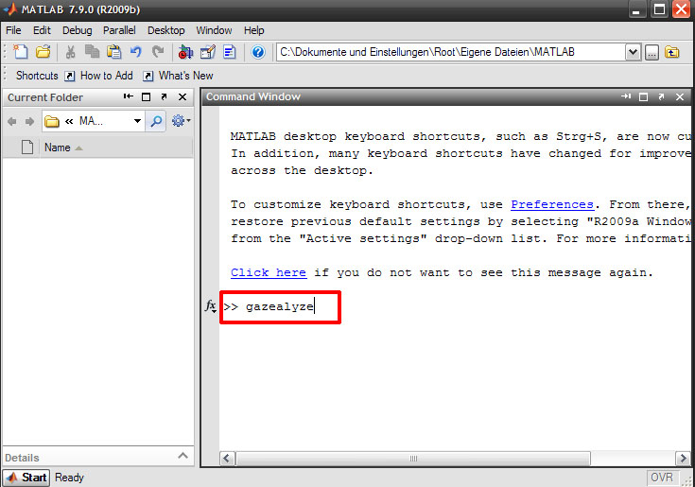

The GazeAlyze main window will pop up and your first step will be to create a new control script, just choose File -> New Control-Script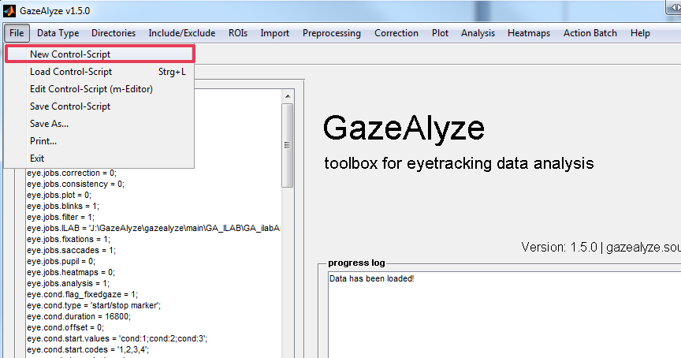

A new control file is generated and you should save your Control-File now. Choose File -> Save as. Type a suitable filename and select a place to save, confirm with the button save.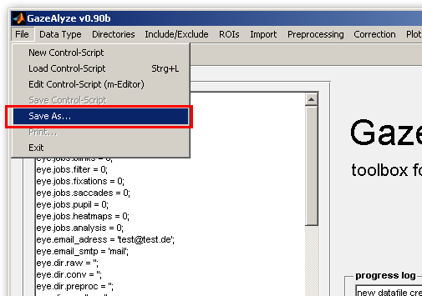

# Data Type

Once your control file is created it is time to choose a data type. Right now three data types IVIEW(SMI) ISCAN and Viewpoint(Arrington) are supported. More data types will follow in the next months.

In this example we will deal with Viewpoint data. But the instruction for an ISCAN and IVIEW file is nearly the same, you would just select IVIEW in this case. Please select now Data Type -> Viewpoint

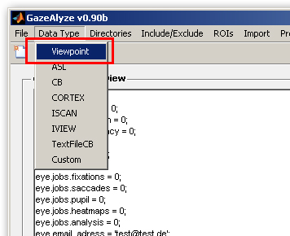

# Directories

The most important step is to choose the right directories without doing this GA has no files to work with. Go ahead and select: Directories -> Edit Directories

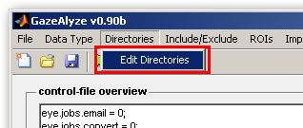

The following window will pop up, it is divided by numbers and we will work them off one by one.

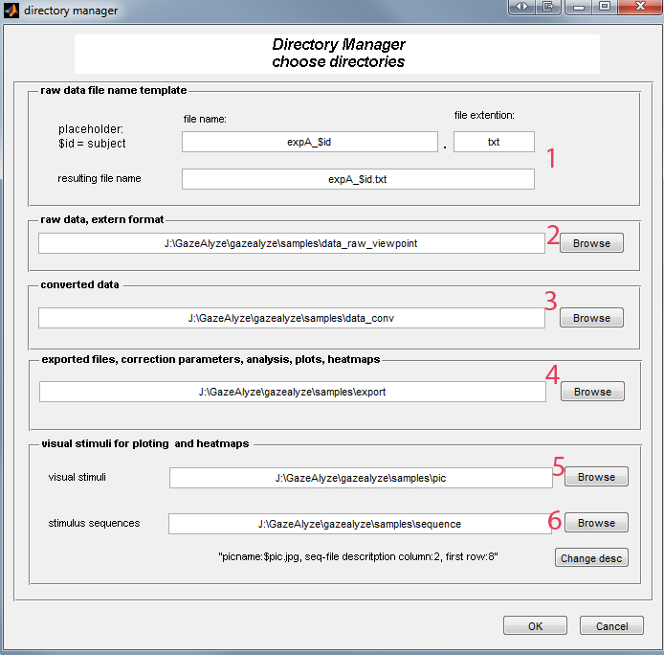

1. The file description means the unique file identifier. The part of the file that is different from all other files. The placeholder for the unique file identifier is $id. That may sound confusing in the first moment, thus we will show you a small example:

If your file is named IAPS_G0983.txt your file identifier is G0983 and you would type in the text box IAPS_$id. This is needed to link the different files to each other.

2. The basic directory is the directory that holds the raw eye tracker log files containing the eye movement data in raw format(e.g. the Viewpoint-files).

3. The next directory is the directory where GA will put the imported and converted files (GA imports the log files and converts them to an MATLAB-variable structure that is readable by ILAB. Also all other analysis steps will put there data structure into this files and additionally text files with fixations and saccades will be stored into this folder

4. This directory is the output folder for the ILAB-processed data. In this folder new subfolders will be created automatically for heatmaps, plots, correction factors and analysis.

5. and 6. If you wish to plot or work with heatmaps you have to select two folders here. The first folder should hold the stimulus material (pictures). The second folder should hold the stimulus sequence files that show the order of appearance of the stimulus material. The stimulus sequence will also be used by the analysis function for output of aggregated data for further statistics

With the button “Change desc” you have also the ability to specify the placeholder for the pic string from the sequence file. E.g. "1050.jpg" would be a picture which was used in an experiment. In the sequence file were only reported the picture name "1050" without the file ending ".jpg". Only 1050 would result in $jpg. So you have to add $pic and ".jpg" to get the complete filename. See the pictures below for an example. The column and row just specify where your data starts in your sequence files. Sequence files normally have a header that should be skipped and maybe more than one column with data.

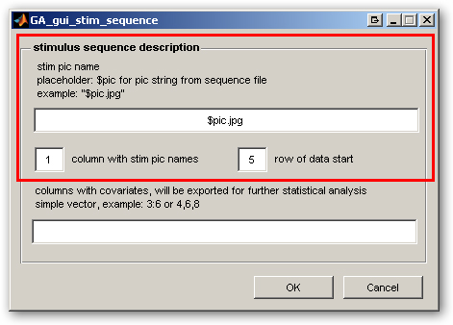

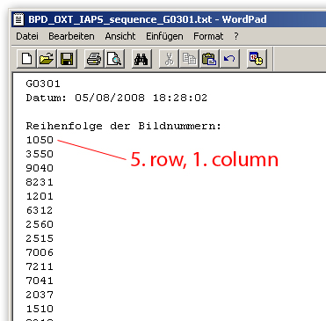

There is also a field for covariates that can be exported and be used in further analysis. This will not be used in this example. Just leave it blank.

# Import

Now we have to set up the trial settings. You can do this by choosing Import -> Trial Import Settings

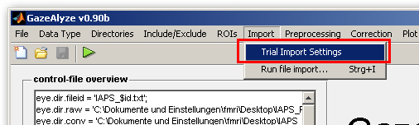

A new window will appear which is segmented into 3 parts. We will explain them one by one.

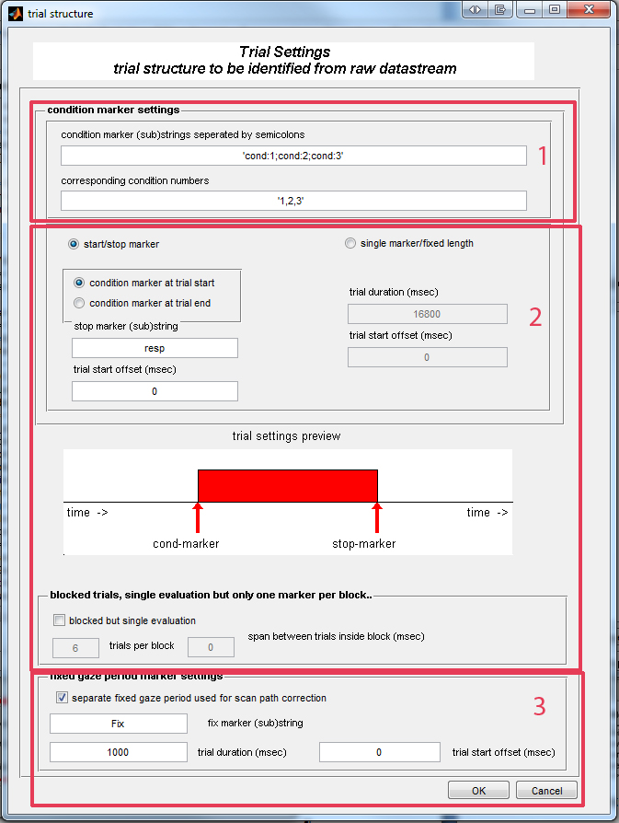

1. The trial marker settings will describe the name of the used condition markers they have to be divided by semicolons. In this example they are cond_1; cond_2; cond_3. These conditions can be grouped by the corresponding condition numbers. In our example they were not grouped. Each marker identifies another condition

2. Second you have to choose whether you have a start marker and a stop marker or a start marker and a fixed length. If you choose start/stop-marker you have to give the name of the stop marker, and the trial offset if there is any. The condition marker is normally set at the trial start, if not you can switch it with the radio button.

Optional you can also choose blocked trials. Check the blocked marker field and fill in how many trials are blocked in a single block and if there is any span between them.

3. The third field can declare an optional fixed gaze period used for scan path correction. If you have a fixed gaze period related to each trial (e.g. normally a fixation cross) this can be used to determine correction parameters. Therefore you have to enter the string of the fixed gaze period marker, the trial duration and, if needed a trial start offset.

Now you can select Import -> Run file import

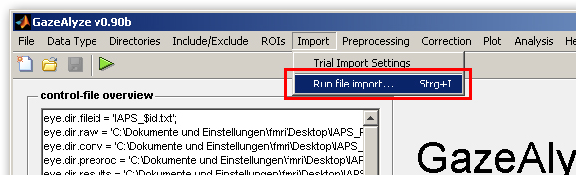

If everything is properly set GazeAlyze should now import your files and convert them.

# Preprocessing

The next and last step in this tutorial will be the preprocessing. We will process the log files with ILAB and after that they are ready for further analysis and visualizations.

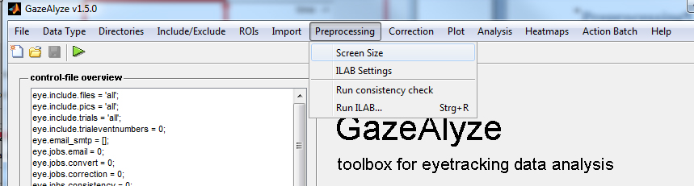

We have to choose the screen size first. Select Preprocessing -> Screen Size

The following window will pop up:

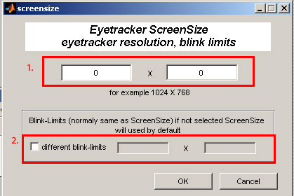

1. Now you have to enter the eye tracker resolution this would be in our example 1024x768 pixel.

2. This step is optional and normally not needed. If you would like to calculate blink limits not on the complete resolution you can enable this option and give different blink limits.

After that select Preprocessing -> ILAB Settings

In this window you just have to checkmark what ILAB should do. For example blink detection. If you are not sure select everything.

Under the advanced ILAB setting you can choose the file where the settings for the ILAB jobs are stored. Button Edit opens the m-file editor of GA_ilabAnalysisParms.m (or your special file)where you can edit the ILAB settings. You can change the preset options depending to your experimental geometry settings.

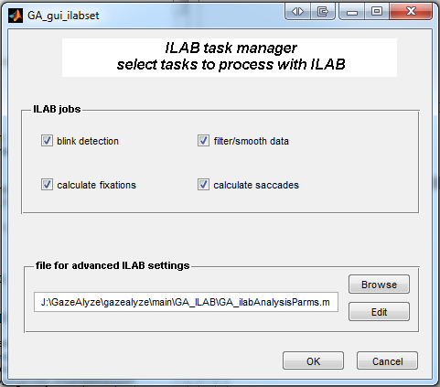

The last step is to select Preprocessing -> Run ILAB and ILAB should start processing the files. The results will be stored in your converted data folder.

# Finished

Now you have a basic set of data ready for all following steps as calculate possible correction parameter, analysis, plots or heatmaps.